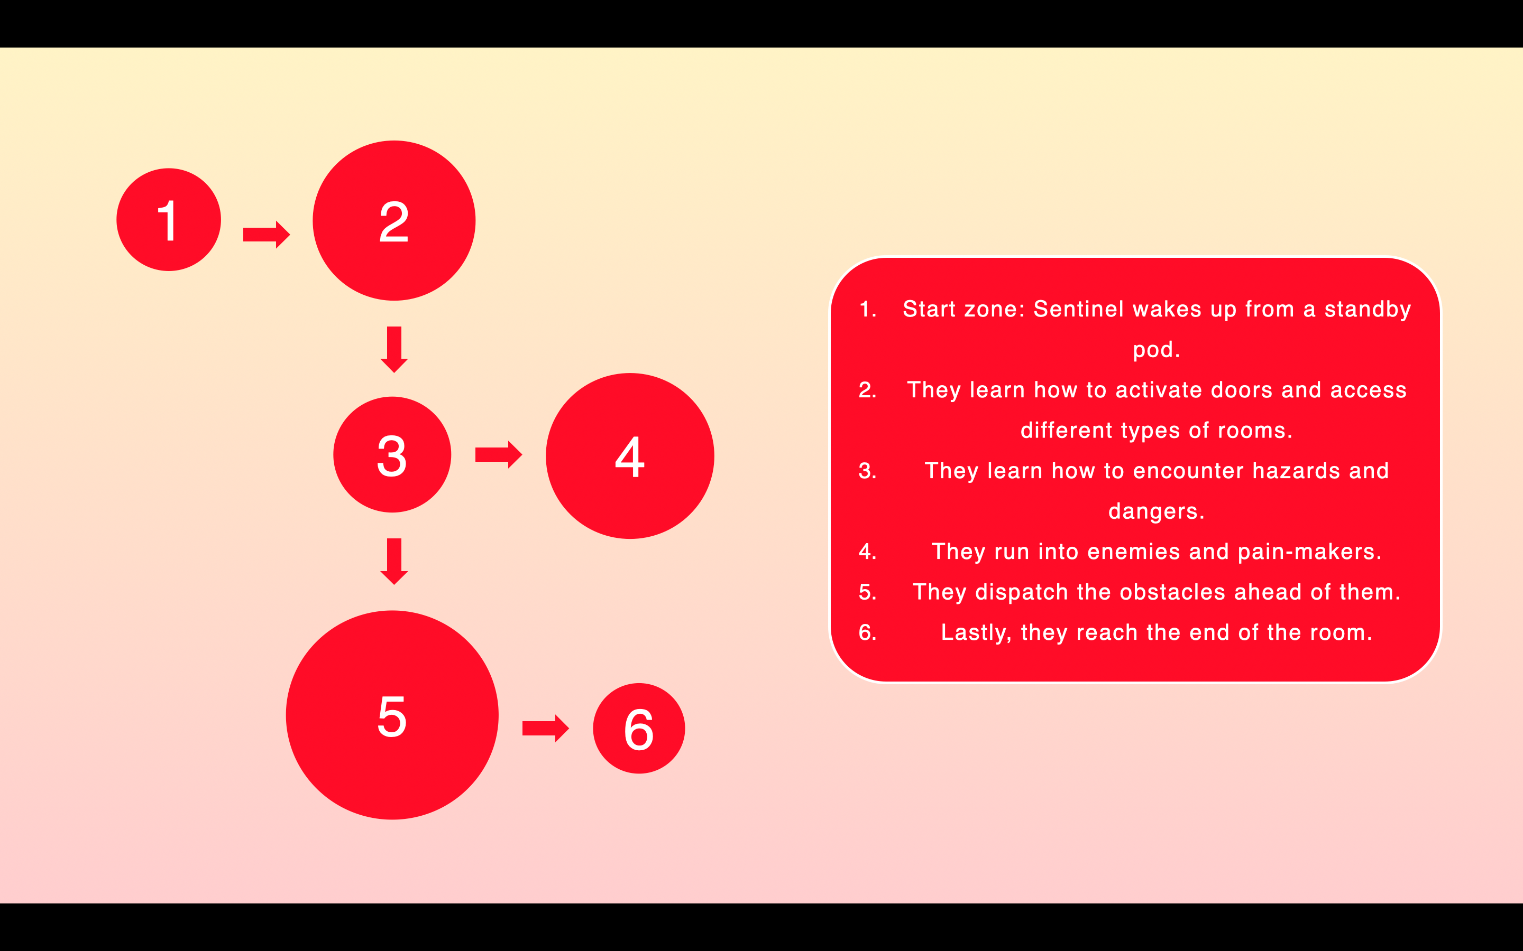
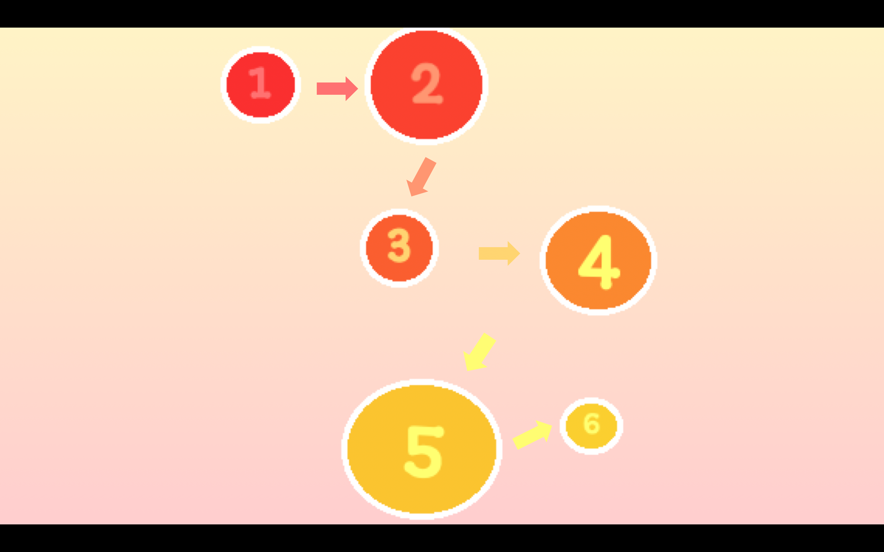
Week 1 - complete!
I created some design planning via bubble maps and pixel maps

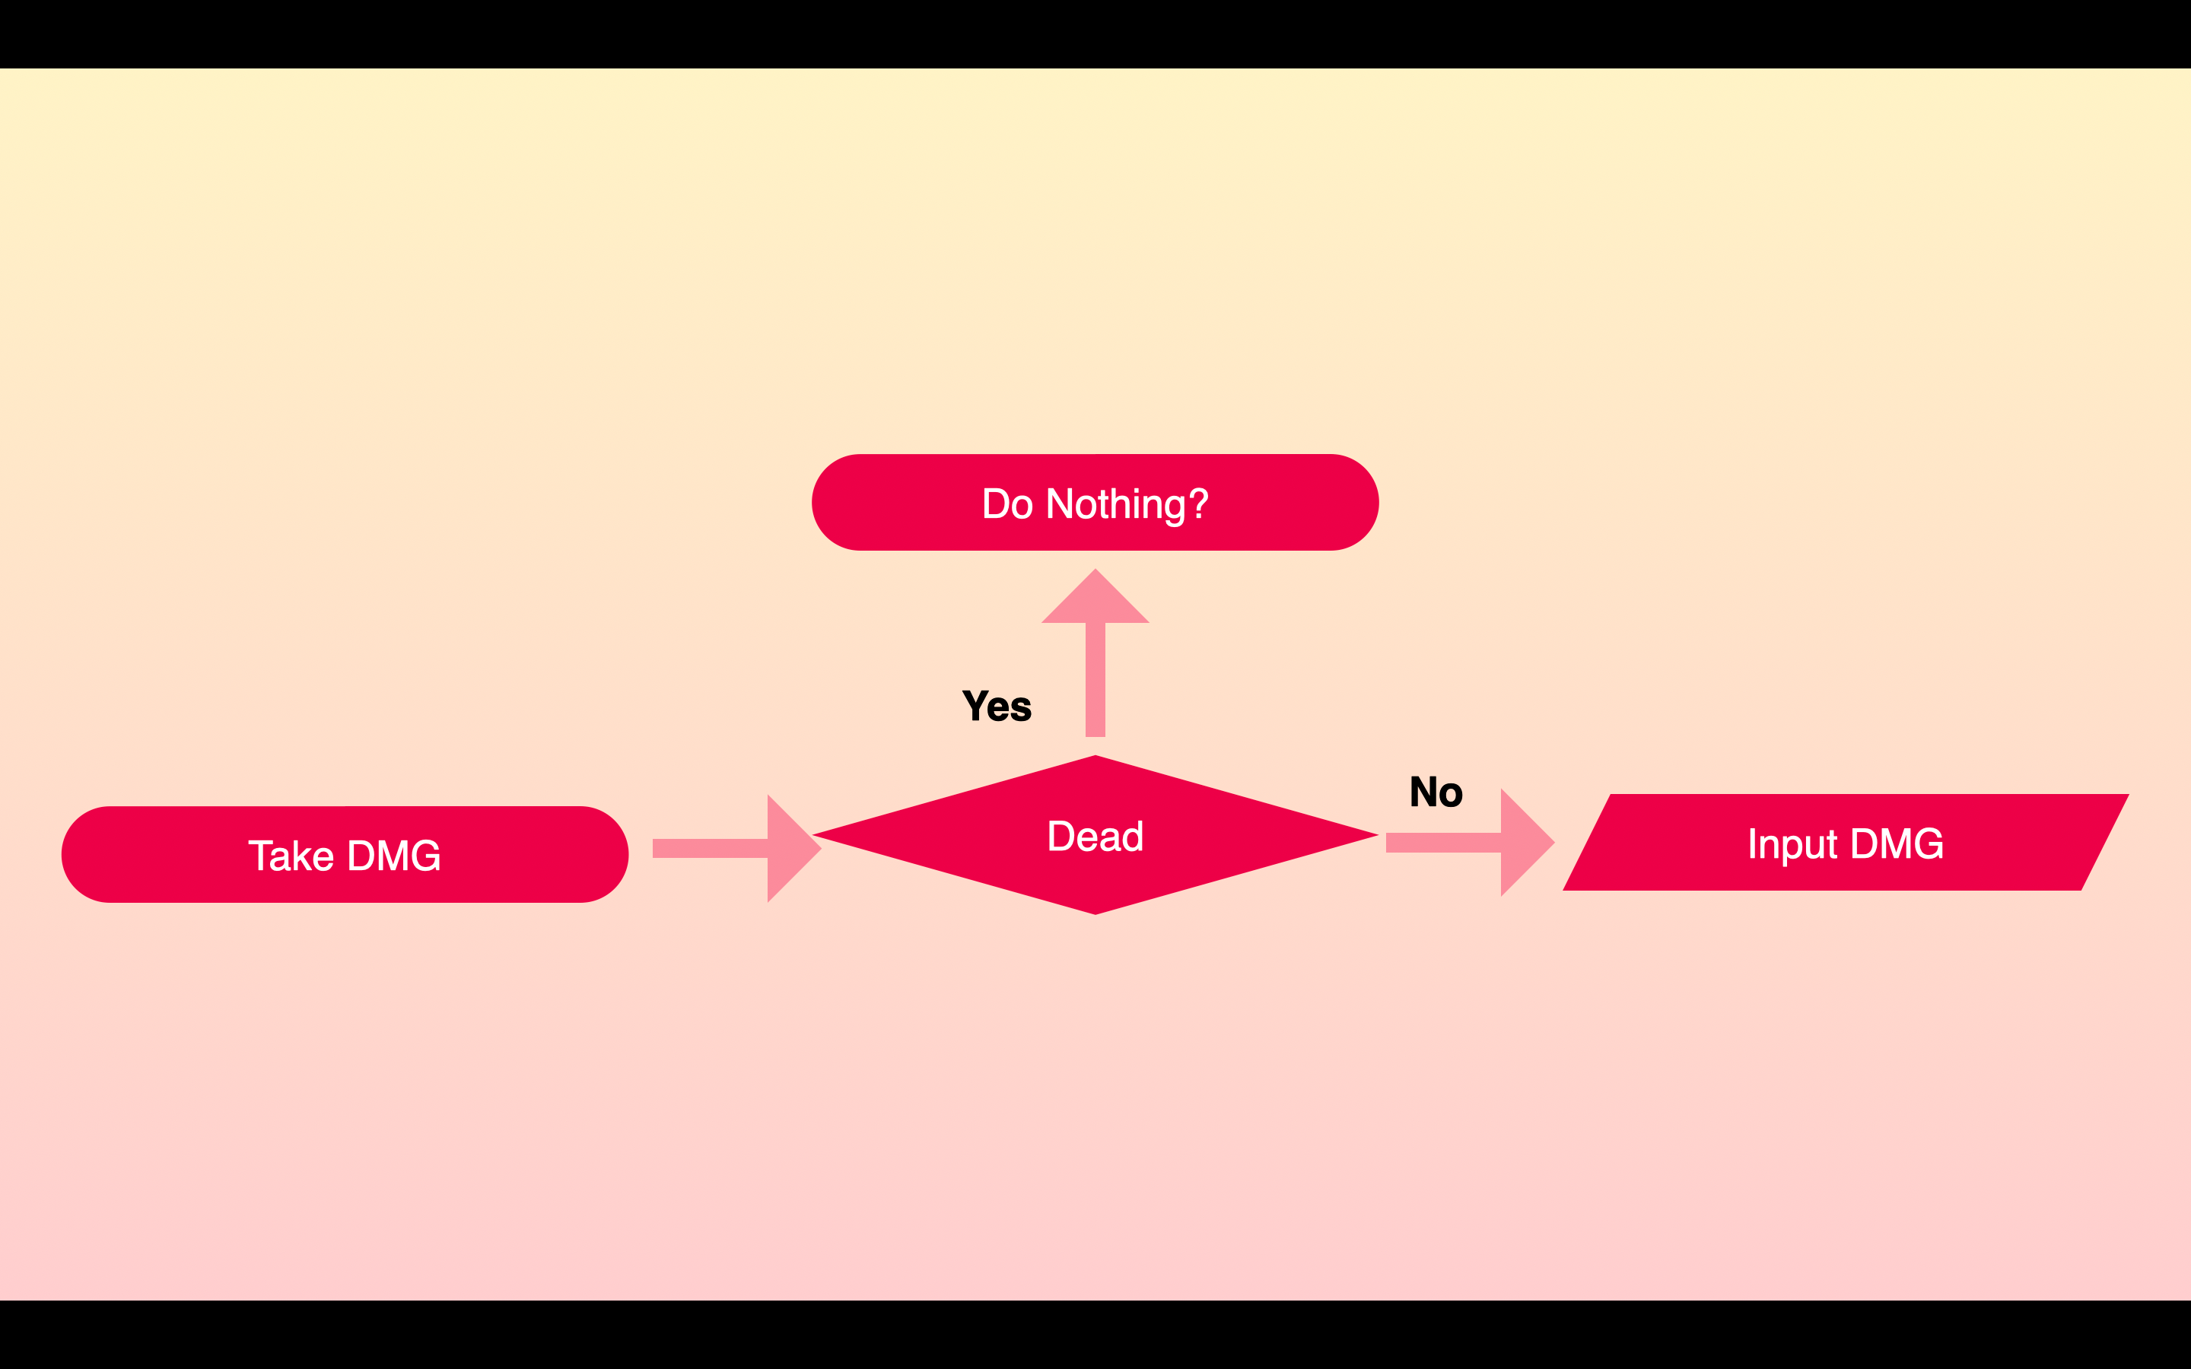
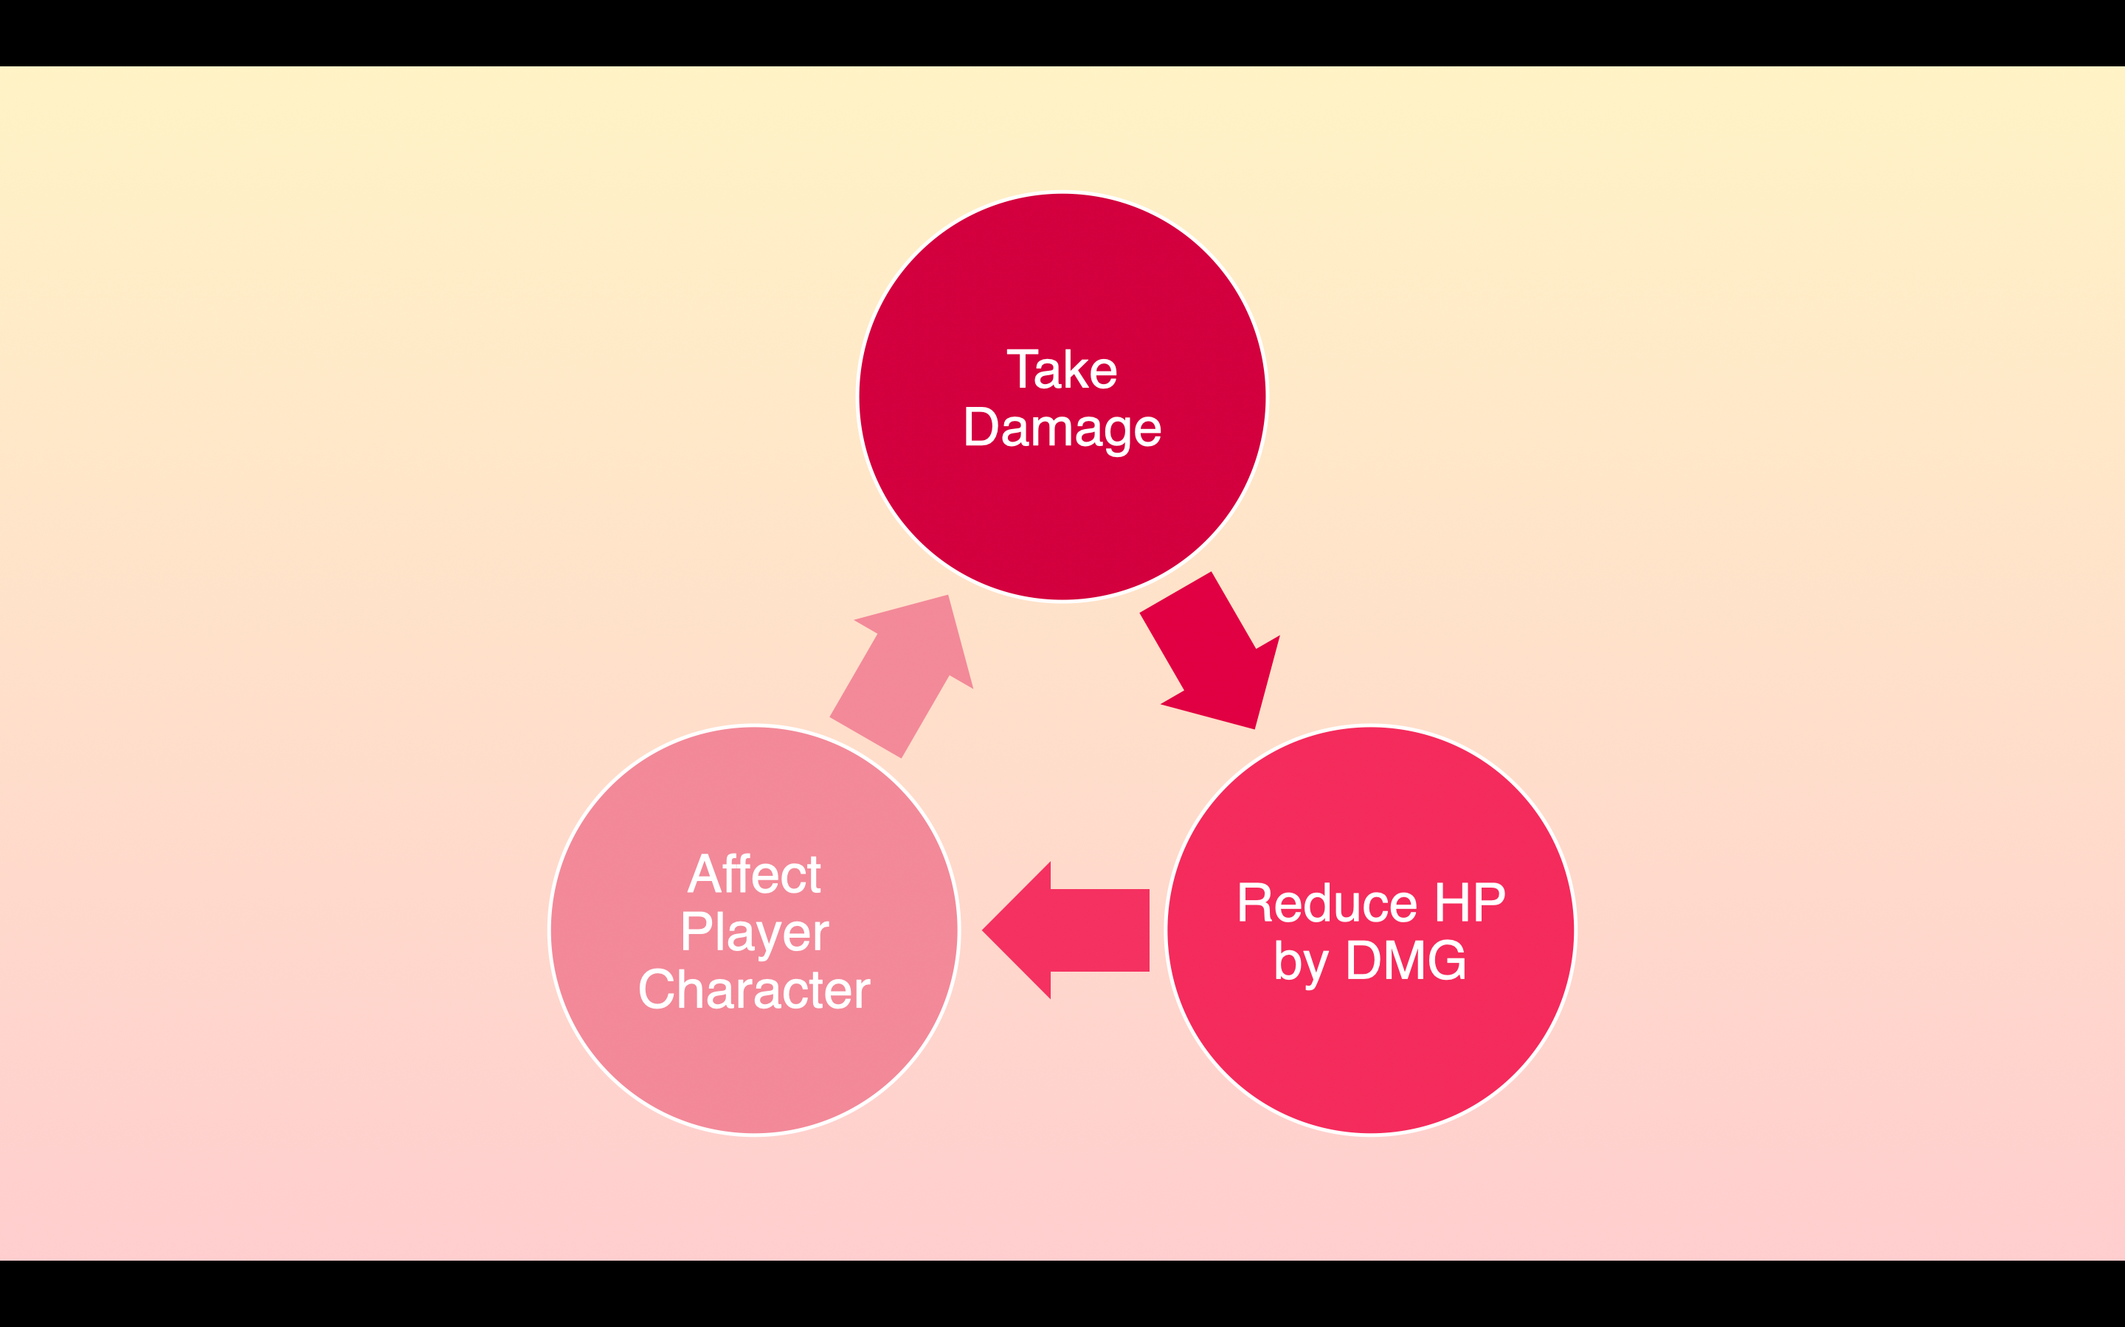

Week 2 – complete!
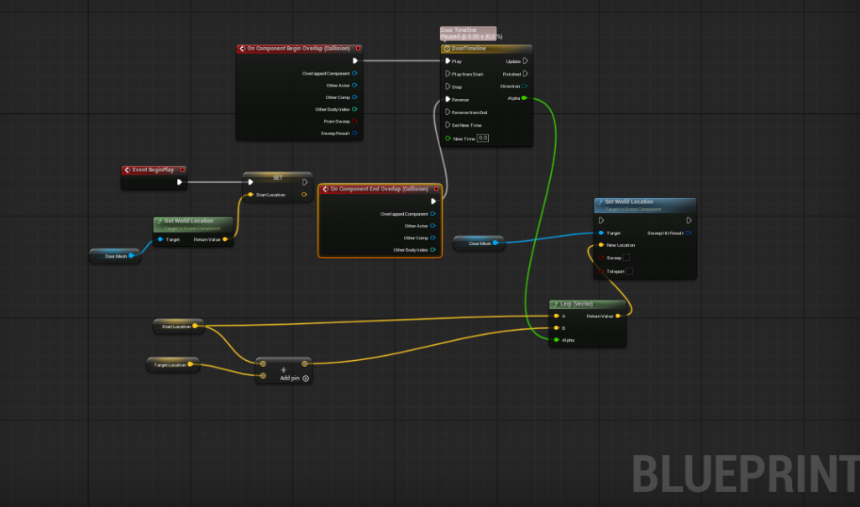
Using game loop pseudocode and flow diagrams, I designed the player’s damage system. I also created a hazard like a laser wall, which causes damage through simple collisions using system design planning tools. In future weeks, I’ll demonstrate how my doors platforms and triggers work in the game using design planning tools.

Week 3 – complete!
I designed the functionality of my doors and platforms using flow diagrams pseudocode and game loops. I considered the level of affordance I wanted to incorporate into your design including triggers colours meshing and particles. I also performed meshing on my doors and platforms to enhance affordance within the level. I’ve been trying to post images of my logic planning and meshing to the forum.
Week 4 - complete!
As I worked on a physics puzzle, I applied the techniques we learned in class. I used physics principles and actor communication to open a door and build on the approach to create a unique and engaging puzzle. I then recorded myself completing it and posted the video to the forum thread to show proof on how I did it all.

